
B
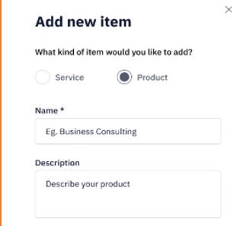
Write HTML Code (6)
How to write CSS code Internally (2)
Differentiate Id and class Selectors with 1 Example(2)

Write HTML Code (6)
How to connect external CSS file (2)
Differentiate block and inline elements with 1 Example(2)

